Some rationales are written with assistance of an LLM

Header

LLM Response:
Implement Staggered Scheduling for LLM-Generated Interactions

Rationale:

Rationale remains the same.

The header given by the LLM provides a concise but specific description of the user story’s desired feature. The LLM suggested various other titles (viewable in the logs), but this one was selected since it conveyed the main idea of the feature the clearest, with the other titles being too technical or too wordy, to the point where it strayed too far from what the baseline user story was asking for.

This third user story is set up well by the other two. Story 5 sets up the scenario/environment by providing the basic features of a social media environment, while story 6 provides the foundation for the LLM-generated responses, with this user story expounding upon the LLM’s functionality.

Architecture Diagram

LLM Response:
The implemented architecture differs from the original spec in several key ways. The system uses APScheduler with a SQLAlchemy-backed persistent job store instead of Celery + Redis for job orchestration, Anthropic Claude Haiku as the LLM provider, and Flask-SQLAlchemy for all data persistence. Scheduled jobs survive server restarts because APScheduler persists them to the same PostgreSQL database used by the application. There is no separate cache layer (Redis) — activity scores are computed on-the-fly from the database.
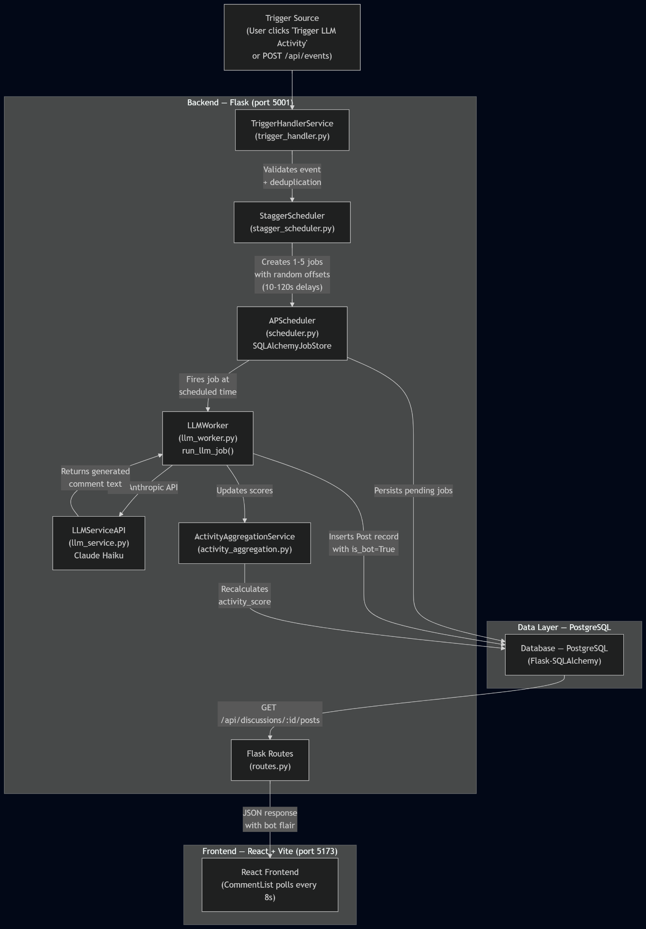

Rationale:
The implemented architecture is simpler than originally planned. Instead of a multi-service approach with Celery workers and Redis queues, the team used APScheduler running in-process with Flask. APScheduler is configured with a SQLAlchemyJobStore that persists pending jobs to the same PostgreSQL database used by the application, so scheduled jobs survive server restarts. On startup, init_scheduler() reconnects to the job store and resumes any pending jobs. This eliminates the original persistence risk without introducing new infrastructure dependencies.

List of Classes

LLM Response:

1. Trigger / Event Layer
- TriggerHandlerService (trigger_handler.py)
  - Purpose: Receives trigger events from the /api/events endpoint and dispatches staggered jobs.
  - Methods: handle_event(event_type, artist_id) — validates, deduplicates, and calls StaggerScheduler.

2. Orchestration / Scheduling Layer
- StaggerScheduler (stagger_scheduler.py)
  - Purpose: Calculates random time offsets (10–120 seconds) for each bot persona and schedules jobs.
  - Methods: schedule_jobs(artist_id, discussion_id) — selects 1–5 LLMPersona records, computes offsets, and enqueues jobs in APScheduler.
- APScheduler Singleton (scheduler.py)
  - Purpose: Initializes a BackgroundScheduler with a SQLAlchemyJobStore backed by PostgreSQL, and holds a reference to the Flask app for job execution context.
  - Fields: scheduler (APScheduler BackgroundScheduler with SQLAlchemy job store), _flask_app (Flask app reference).
  - Functions: init_scheduler(app) — reads SQLALCHEMY_DATABASE_URI from app config, creates the SQLAlchemy job store, starts the scheduler. get_flask_app() — returns the stored Flask app reference for background job context.
- LLMJob (SQLAlchemy model in models.py)
  - Purpose: Persists scheduled job metadata for tracking and debugging.
  - Fields: id, artist_id, discussion_id, llm_persona_id, scheduled_time, status (pending/completed/failed), created_at, completed_at.

3. Execution Layer
- run_llm_job() (llm_worker.py)
  - Purpose: Executed by APScheduler at the scheduled time. Generates a comment and inserts it as a Post.
  - Flow: Loads LLMPersona → calls LLMServiceAPI → creates Post with is_bot=True → calls ActivityAggregationService.
- LLMServiceAPI (llm_service.py)
  - Purpose: Wraps the Anthropic Python SDK to call Claude Haiku (claude-haiku-4-5-20251001).
  - Methods: generate_comment(persona, discussion_context) — sends a prompt with persona style and recent posts, returns 1–3 sentence comment text.

4. Application Layer
- Routes (routes.py)
  - POST /api/events — receives trigger events, calls TriggerHandlerService.
  - GET /api/discussions/<id>/posts — returns paginated posts including bot comments.
  - GET /api/artists — returns paginated artist list with activity scores.
- Auth Routes (auth_routes.py)
  - POST /api/auth/register, /login, /logout, GET /api/auth/me — user authentication via Flask sessions.
- List Routes (list_routes.py)
  - GET /api/lists, POST /api/lists, GET /api/lists/<id> — curated album lists.

5. Data Models (SQLAlchemy in models.py)
- Artist — id, name, image, bio, activity_score, discussion_count, genres (M2M).
- Genre — id, name, many-to-many with Artist.
- User — id, display_name, handle, email, password_hash, is_bot, bot_label, created_at.
- LLMPersona — id, user_id (FK → User), name, engagement_style, genre_familiarity.
- Discussion — id, artist_id (FK → Artist), title, created_at, post_count, last_activity_at.
- Post — id, discussion_id (FK → Discussion), author_user_id (FK → User), body, created_at, is_deleted.
- Album — id, artist_id, title, cover_image, release_date, album_type, genre (FK).
- ListModel / ListAlbum — curated lists with album associations.
- LLMJob — id, artist_id, discussion_id, llm_persona_id, scheduled_time, status, created_at, completed_at.

6. Activity & Discovery
- ActivityAggregationService (activity_aggregation.py)
  - Purpose: Recalculates artist activity_score and discussion_count after each bot post.
  - Methods: update_artist_activity(artist_id).

7. Frontend Components (Relevant to Story 10)
- CommentList — Polls GET /api/discussions/:id/posts every 8 seconds via React Query.
- CommentItem — Renders individual post content with UserBadge.
- UserBadge — Displays displayName, handle, and a "BOT" badge when is_bot=True.
- ArtistPage — Shows artist hero, discussions, and a "Trigger LLM Activity" button.

Rationale:
The implemented class structure is leaner than the original spec proposed. Instead of separate TriggerEvent, JobQueue, LLMPostJob, StaggerConfig, Comment, CommentWithAuthor, CacheManager, DiscoveryPage, and FilterCriteria classes, the implementation consolidates into fewer models (Post instead of Comment, LLMJob instead of LLMPostJob, no separate StaggerConfig — config is inline). This is a pragmatic choice for a project of this scope.

Class Diagram

LLM Response:
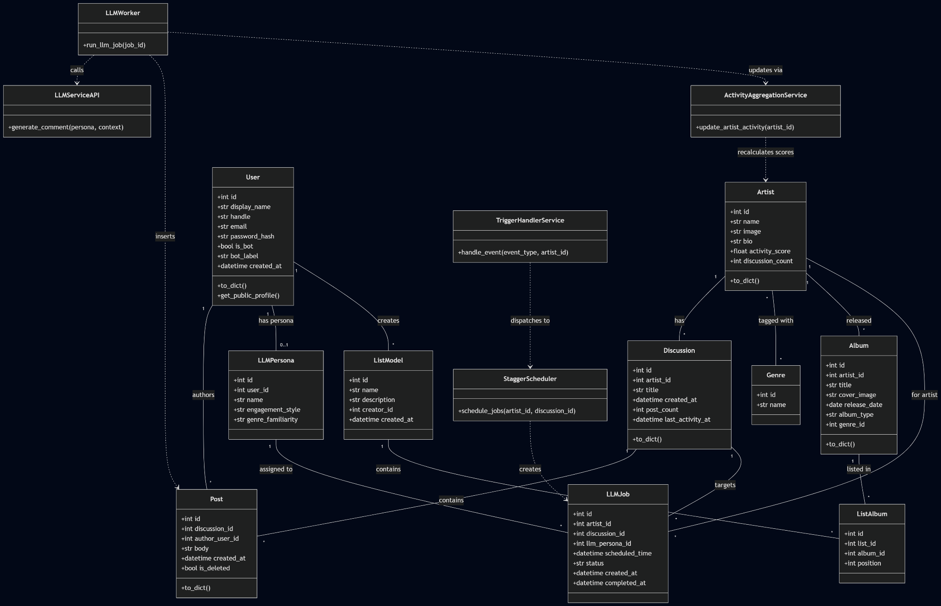

Rationale:
The class diagram reflects the actual SQLAlchemy models and service classes in the repository. Compared to the original spec, the relationships are simpler — there is no separate CommentWithAuthor view model (the route handler joins User data inline), no CacheManager (no Redis layer), and the LLMPersona is a first-class model linked to a User rather than a configuration object.

State Diagrams

LLM Response:
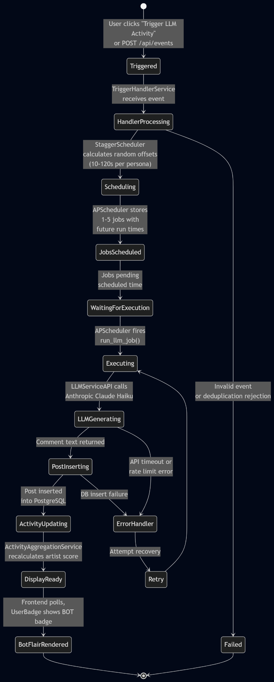

Rationale:
The state diagram reflects the actual flow through the implemented services. Key differences from the original spec: there is no separate CommentInserted → ActivityUpdated distinction at the database level (it happens in one transaction in run_llm_job), and the RenderBot state is now represented by the frontend's UserBadge component rendering the BOT badge based on the is_bot flag returned in the API response.

Flow Chart

LLM Response:
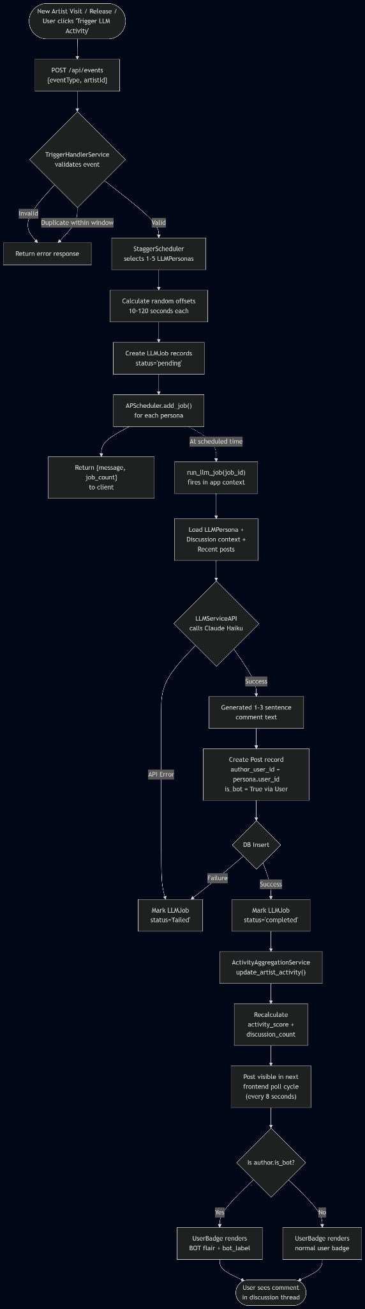

Rationale:
The flow chart maps directly to the implemented code path. Unlike the original spec which showed three separate retry paths (for scheduling, LLM errors, and DB errors), the implementation has a simpler error model — jobs are marked failed and can be inspected, but there is no automatic retry mechanism built into APScheduler at this stage.

Development Risks and Failures

LLM Response:

1. Triggering & Event Handling Risks
Implementation status: Handled via TriggerHandlerService with event validation and deduplication.
- Resolved risk: Job persistence — APScheduler now uses a SQLAlchemyJobStore backed by PostgreSQL, so pending jobs survive server restarts.
- Remaining risk: No persistent event log separate from the LLMJob table. If deduplication logic needs to span restarts, it must query the LLMJob table.
- Mitigation implemented: Idempotent seed logic; LLMJob table provides an audit trail; SQLAlchemy job store provides execution persistence.

2. Scheduling / Orchestration Risks
Implementation status: StaggerScheduler uses Python's random.randint(10, 120) for offset calculation. APScheduler is initialized via init_scheduler(app) with a SQLAlchemyJobStore that reads SQLALCHEMY_DATABASE_URI from Flask config.
- Resolved risk: Job loss on restart — the SQLAlchemy job store persists all pending jobs to PostgreSQL. When Flask restarts and calls init_scheduler(), the scheduler reconnects to the same job store and resumes pending jobs.
- Remaining risk: Misfire handling — if the server is down when a job's scheduled time passes, APScheduler's default misfire_grace_time determines whether the job runs late or is skipped. A generous grace time (e.g., 300 seconds) should be configured so staggered comments still post after brief outages.
- Mitigation implemented: use_reloader=False prevents duplicate scheduler instances. init_scheduler() checks scheduler.running before starting to avoid double-start.

3. LLM Service Risks
Implementation status: LLMServiceAPI wraps the Anthropic SDK calling claude-haiku-4-5-20251001.
- Remaining risk: No retry logic on API failures, no output moderation filter beyond the LLM's built-in safety.
- Mitigation implemented: Try/catch in run_llm_job marks jobs as failed on error. Claude Haiku's built-in content safety provides baseline filtering.

4. Application Layer / DB Risks
Implementation status: Flask-SQLAlchemy with PostgreSQL. Post insertion and activity updates happen in run_llm_job.
- Remaining risk: No explicit transaction management around the post-insert + activity-update sequence — a crash between them could leave scores stale.
- Mitigation implemented: SQLAlchemy's session auto-commits provide basic transactional behavior.

5. Frontend Rendering Risks
Implementation status: React Query polls every 8 seconds via useQuery with refetchInterval: 8000.
- Remaining risk: High polling frequency on large threads could cause unnecessary load. No WebSocket/SSE for real-time push.
- Mitigation implemented: Paginated responses limit payload size. 8-second interval is a reasonable compromise.

6. Ethical / User Perception Risks
Implementation status: All bot posts are transparently labeled with a BOT badge via UserBadge component.
- Remaining risk: If too many bot posts appear relative to human posts, engagement may feel synthetic.
- Mitigation implemented: Limited to 1–5 bot personas per trigger event. Bot label is always visible.

Rationale:
A lot of the risks and failures mentioned in the original user story document were handled during the backend implementation, making for a safer and less error-prone project. However, there are some remaining risks to take into consideration in the testing phase of the project.

Technology Stack

LLM Response:
Layer | Original Spec | Actual Implementation
Frontend Framework | React.js + TypeScript | React 18 + TypeScript + Vite 6
Routing | React Router | React Router 7 (createBrowserRouter)
State Management | Zustand | TanStack React Query 5 (no Zustand)
UI Library | Tailwind CSS | Tailwind CSS v4 + Radix UI primitives
Data Fetching | React Query | TanStack React Query 5 (useQuery)
Backend Framework | Python + Flask | Flask + Flask-SQLAlchemy + Flask-CORS
Background Jobs | Celery + Redis/RabbitMQ | APScheduler (in-process, SQLAlchemy-persisted job store)
Database | PostgreSQL | PostgreSQL (crescendo_p4)
ORM | SQLAlchemy | Flask-SQLAlchemy
Cache Layer | Redis | None (scores computed from DB)
LLM Provider | OpenAI / Hugging Face / other | Anthropic Claude Haiku (claude-haiku-4-5-20251001)
LLM SDK | Not specified | Anthropic Python SDK
Monitoring | Prometheus + Grafana | Not implemented
Error Tracking | Sentry / Rollbar | Not implemented
Analytics | Mixpanel / PostHog | Not implemented

Rationale:
The implemented stack is significantly simpler. The biggest change is replacing Celery + Redis with APScheduler backed by a SQLAlchemyJobStore. This eliminates the need for a separate message broker and worker processes while still providing job persistence across server restarts — pending jobs are stored in the same PostgreSQL database and automatically resumed on startup. The switch from OpenAI to Anthropic Claude Haiku reflects an actual provider choice rather than the generic "LLM provider" in the original spec.

APIs

LLM Response:

1. Event Trigger API
- Endpoint: POST /api/events
- Payload: { "eventType": "new_artist" | "new_release" | "page_activation", "artistId": <int> }
- Response: { "message": "Scheduled N bot responses", "job_count": N }
- Flow: Validates → TriggerHandlerService → StaggerScheduler → APScheduler jobs created → LLMJob records inserted.

2. Artist List API
- Endpoint: GET /api/artists
- Query Params: active_discussions (bool), genre (str), sort (str), page (int), per_page (int)
- Response: { "artists": [...], "total": N, "page": N, "pages": N }
- Notes: Each artist object includes activityScore, discussionCount, latestThread, and genres (camelCase).

3. Artist Detail API
- Endpoint: GET /api/artists/<id>
- Response: Single artist object with full detail.

4. Discussions API
- Endpoint: GET /api/artists/<id>/discussions
- Query Params: page, per_page
- Response: { "discussions": [...], "total": N, "page": N, "pages": N }

5. Discussion Posts API
- Endpoint: GET /api/discussions/<id>/posts
- Query Params: page, per_page
- Response: { "posts": [...], "total": N, "page": N, "pages": N, "discussion": {...} }
- Notes: Each post includes author info with is_bot and bot_label for frontend flair rendering.

6. All Discussions API
- Endpoint: GET /api/discussions
- Query Params: Sort by recent or popular.

7. Genre List API
- Endpoint: GET /api/genres
- Response: { "genres": [...] }

8. Albums API
- Endpoint: GET /api/albums
- Query Params: genre, type, time_range, page, per_page

9. Album Genres API
- Endpoint: GET /api/albums/genres
- Response: Genres with album counts and cover images.

10. Search API
- Endpoint: GET /api/search?q=<query>
- Notes: Minimum 2 characters. Searches artists and albums.

11. Platform Stats API
- Endpoint: GET /api/stats
- Response: Platform-wide statistics.

12. Curated Lists APIs
- GET /api/lists — all lists
- POST /api/lists — create new list
- GET /api/lists/<id> — list detail with albums

13. Authentication APIs
- POST /api/auth/register — register new account
- POST /api/auth/login — log in
- POST /api/auth/logout — log out
- GET /api/auth/me — current session user

14. Post Submission API
- Endpoint: POST /api/discussions/<id>/posts
- Payload: { "body": "...", "author_user_id": <int> }
- Notes: Used by both human users and the LLM worker (programmatically).

Rationale:
The implemented API surface is broader than the original spec anticipated. The original focused narrowly on the staggered scheduling endpoints, while the actual implementation includes full CRUD for albums, lists, search, authentication, and platform stats — reflecting the full application scope rather than just Story 10 in isolation.

Public Interfaces

LLM Response:

Comment Display Components
- CommentList (CommentList.tsx) — Fetches posts via React Query with refetchInterval: 8000 (8-second polling). Displays bot and human posts in the same list.
- CommentItem (CommentItem.tsx) — Renders individual post content with relative timestamps and author info via UserBadge.
- UserBadge (UserBadge.tsx) — Props: displayName, handle, isBot, botLabel. Renders a "BOT" badge for LLM-generated users.

Pages / Routes
- DiscoveryPage (/) — Uses useQuery to fetch GET /api/artists. Displays artist cards with activity scores reflecting staggered bot engagement.
- ArtistPage (/artists/:id) — Artist hero section, discussion list, and a "Trigger LLM Activity" button that calls POST /api/events.
- DiscussionPage (/discussions/:id) — Discussion title + CommentList component showing all posts including staggered bot comments.

Real-Time / Dynamic Features
- Staggered Comment Arrival: As APScheduler fires run_llm_job() at randomized intervals, new posts appear in the discussion. The frontend's 8-second polling cycle picks them up and renders them, simulating organic engagement growth.
- Activity Metric Updates: Artist cards on the discovery page reflect updated activityScore and discussionCount after bot posts are inserted.
- Bot Flair Rendering: UserBadge distinguishes LLM users with a visible "BOT" badge, maintaining transparency.

Data Schemas

LLM Response:
Column | Type | Notes
id | INTEGER PK | Auto-increment
display_name | TEXT | Required
handle | TEXT | Unique
email | TEXT | Unique, nullable (bots may not have email)
password_hash | TEXT | Nullable (bots don't log in)
is_bot | BOOLEAN | Default FALSE
bot_label | TEXT | Nullable (e.g., "Synthetic Fan")
created_at | TIMESTAMP | Default now()

LLM Personas Table
Column | Type | Notes
id | INTEGER PK | Auto-increment
user_id | INTEGER FK → users(id) | Links persona to a User record
name | TEXT | Persona display name
engagement_style | TEXT | e.g., "enthusiastic", "analytical"
genre_familiarity | TEXT | Genres this persona knows about

Artists Table
Column | Type | Notes
id | INTEGER PK | Auto-increment
name | TEXT | Required
image | TEXT | URL to artist image
bio | TEXT | Artist biography
activity_score | FLOAT | Computed by ActivityAggregationService
discussion_count | INTEGER | Count of active discussions

Genres Table + artist_genres (M2M)
Column | Type | Notes
id | INTEGER PK | Auto-increment
name | TEXT | Genre name

Discussions Table
Column | Type | Notes
id | INTEGER PK | Auto-increment
artist_id | INTEGER FK → artists(id) | Which artist this discussion is about
title | TEXT | Discussion title
created_at | TIMESTAMP | Default now()
post_count | INTEGER | Cached count of posts
last_activity_at | TIMESTAMP | Updated on each new post

Posts Table
Column | Type | Notes
id | INTEGER PK | Auto-increment
discussion_id | INTEGER FK → discussions(id) | Parent discussion
author_user_id | INTEGER FK → users(id) | Author (human or bot)
body | TEXT | Post content
created_at | TIMESTAMP | Default now()
is_deleted | BOOLEAN | Default FALSE, for moderation

LLM Jobs Table
Column | Type | Notes
id | INTEGER PK | Auto-increment
artist_id | INTEGER FK → artists(id) | Target artist
discussion_id | INTEGER FK → discussions(id) | Target discussion
llm_persona_id | INTEGER FK → llm_personas(id) | Bot persona assigned
scheduled_time | TIMESTAMP | When job should execute
status | TEXT | "pending", "completed", "failed"
created_at | TIMESTAMP | Default now()
completed_at | TIMESTAMP | Nullable, set on completion

Albums Table
Column | Type | Notes
id | INTEGER PK | Auto-increment
artist_id | INTEGER FK → artists(id) | Album's artist
title | TEXT | Album title
cover_image | TEXT | URL to cover art
release_date | DATE | Release date
album_type | TEXT | "album", "single", "EP"
genre_id | INTEGER FK → genres(id) | Primary genre

Lists Table + List Albums (M2M)
Column | Type | Notes
id | INTEGER PK | Auto-increment
name | TEXT | List name
description | TEXT | List description
creator_id | INTEGER FK → users(id) | List creator
created_at | TIMESTAMP | Default now()

Rationale:
The implemented schema closely follows the original spec's data design with these key differences: (1) LLMPersona is a separate table linked to User rather than just flags on User, (2) the Post model is used instead of Comment (same semantics, different naming), (3) Album and ListModel tables exist for the broader application, and (4) there is no separate ActivityScore table — the score is stored directly on the Artist model.

Security and Privacy

LLM Response:

What Is Implemented
- Flask-CORS configured for cross-origin requests between frontend (port 5173) and backend (port 5001).
- Session-based authentication via Flask sessions with SECRET_KEY signing.
- Password hashing for registered user accounts.
- Bot transparency — is_bot flag and bot_label are always returned in API responses.
- ANTHROPIC_API_KEY stored in .env file (not committed to repo via .gitignore).

What Is Not Implemented (from Original Spec)
- OAuth 2.0 / OIDC (using simple session auth instead).
- Role-based access control (no admin vs user distinction yet).
- Rate limiting on API endpoints.
- CSRF token protection.
- Column-level encryption on sensitive fields.
- TLS enforcement (development runs on HTTP).
- LLM output sanitization/moderation filters beyond Claude's built-in safety.
- Structured logging with PII scrubbing.
- GDPR/CCPA compliance features.

Risks to Completion

LLM Response:

Resolved Risks
- Story 5 Dependency: The trigger environment is fully implemented via POST /api/events and TriggerHandlerService.
- Story 2 Dependency (Bot Flair): Bot flair rendering is implemented via UserBadge with is_bot and bot_label.
- Tech Stack Unity: All three stories share the same Flask + PostgreSQL + React stack.
- APScheduler Persistence: Resolved by configuring APScheduler with a SQLAlchemyJobStore backed by PostgreSQL. Pending jobs now survive server restarts — init_scheduler(app) reconnects to the existing job store on startup and resumes any scheduled jobs.

Remaining Risks
- Misfire Grace Time: If the server is down longer than APScheduler's default misfire_grace_time (1 second), pending jobs will be skipped rather than run late. Should be configured to a higher value (e.g., 300 seconds) so staggered bot comments still post after brief outages.
- No Retry Logic: Failed LLM API calls are marked as failed in the LLMJob table but not automatically retried.
- No Monitoring: No Prometheus/Grafana or Sentry integration. Failed jobs can only be detected by querying the LLMJob table directly.
- Polling vs Push: The 8-second polling interval means there's up to an 8-second delay between a bot post being inserted and the user seeing it. WebSocket or SSE would provide a better UX.
- Single-Process Architecture: APScheduler runs in-process with Flask. This works for development but cannot scale horizontally. Production deployment would need a separate worker process or migration to Celery.

